Computer Language Coding Concepts

Creation Behavior Of Command Calls in a Diagram
The creation behavior of command calls was already explained in the article Creation Behavior Of Command Calls. The current article demonstrates the concept in a diagram.

The steps of creation of a command are clarified with diagrams.

At first, the parent command is in the current state:

- The parent command is already created:

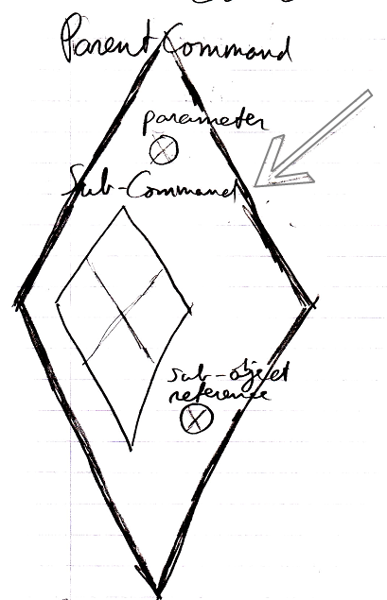

- The parent command’s own parameters / public contents are also already created:

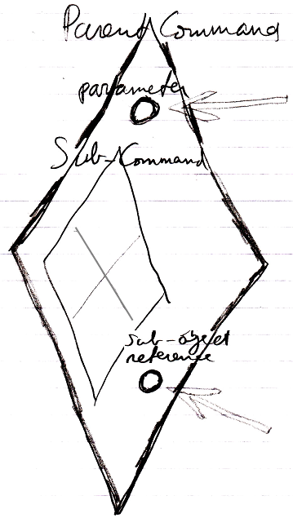

- The parent command’s own parameters are already filled in:

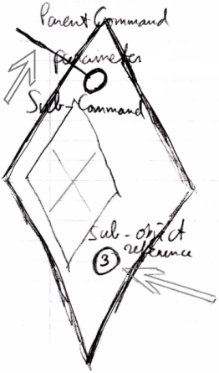

- And the parent command’s private objects are also created.

Before the parent command is run, the following happens:

- All sub-commands are created

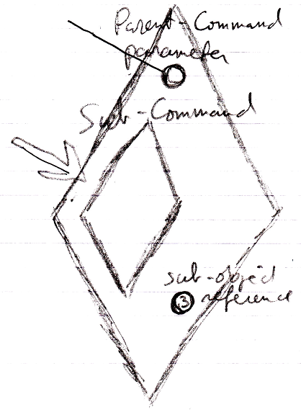

- The sub-commands’ parameters / public contents are there, but left empty:

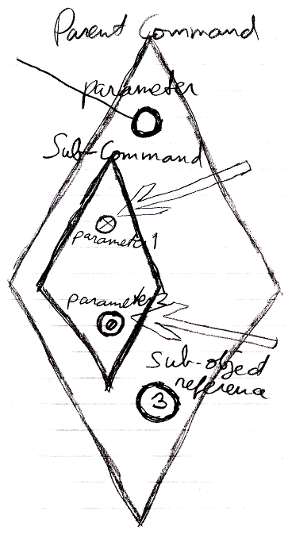

Reference parameters and object out parameters are Nothing (see first arrow above), value parameters are created and initialized with a default value (see second arrow above).

- Mind, that the sub-command’s private contents are not created, which includes its private objects, command calls and clauses.

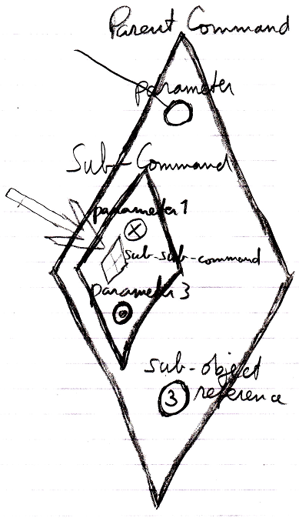

- Parameters passings are created, which are assignments to sub-commands’ parameters, that reference sub-commands’ empty parameters.

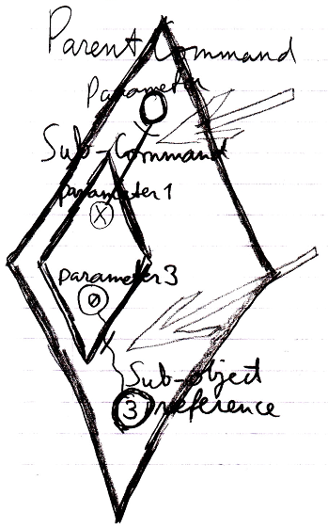

Yes, the parameter passings look like references, but they are not; they are assignments. Parameter passings have an implicit notation, that looks like a reference. They have to be assignment, not references, because after the command executes the parameters are actually destroyed.

Only now, the parent command is ready to run. The sub-command’s public content content needed to be created in order to instantiate the parameter passing assignments, part of the parent command.

See also: Creation Behavior of Command Calls, Commands

Author & Copyright: Jan-Joost van Zon Date: August 2, 2008 – August 7, 2008 Location: Oosterhout, The Netherlands Status: Finished

